Name: | ___________________________________________________ |  |  |  | Date: ___________
 | Year 10 Maths Extension/General  Investigation 2, 2013  Topic - Linear Functions  Take home component
Date out: |  | Week ____ Date _____________ | Date Due: | Week ____ Date _____________
Take home component weighting: |  | 0% of the year | In-class component weighting: | _____% of the year.
AIM: In this assessment, you will be investigating linear functions, in particular:
- drawing their graphs from their equations
- deriving their equations from their graphs and
- deriving their equations from tables of values

PART A GRAPHING LINES
1. | Gradient-intercept form
From middle school, you graphed linear equations of the form
y = mx + c
This form is called the gradient-intercept form. m then is the gradient (steepness) of the line, and c is the y intercept (where the line cuts the y axis).
Examples
a) | y = 2x + 3  the gradient is 2 and the y intercept is 3  NOTE: 2 = 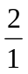 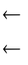 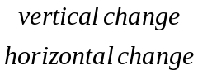  which means for every 1 unit to the right, the graph increases by 2 vertically (positive gradient)  The graph crosses the vertical axis at (0, 3) since the y intercept is 3.  Using these facts, we may sketch the graph – see right |  |  | 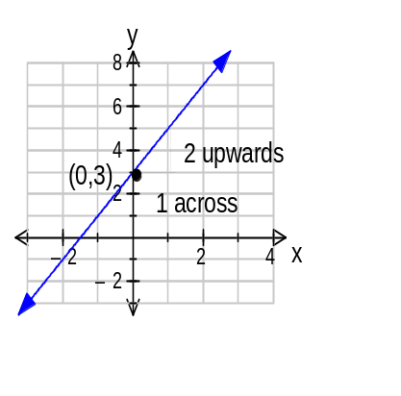
b) | 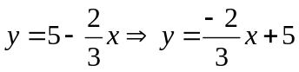  the gradient is - and the y intercept is 5  NOTE: - = 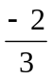  which means for every 3 units to the right, the graph decreases by 2 vertically (negative gradient)  The graph crosses the vertical axis at (0, 5) since the y intercept is 5.  Using these facts, we may sketch the graph – see right |  |  | 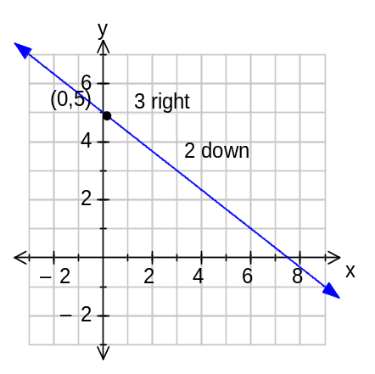
Now sketch the following lines using the method above
c) | 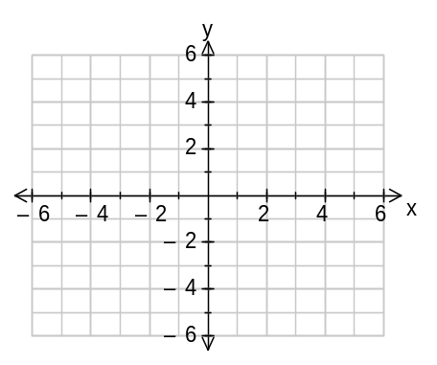  y = x + 2 | d) | 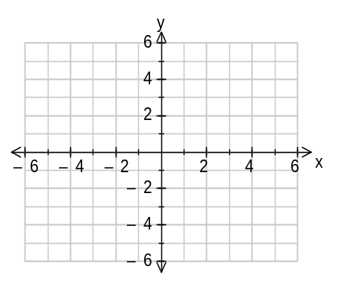  y = 2x – 1
e) | 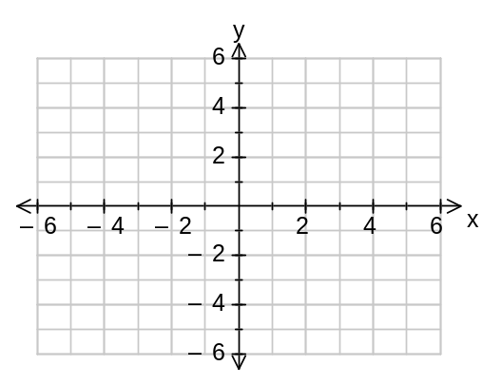  y = 5 - x | f) | 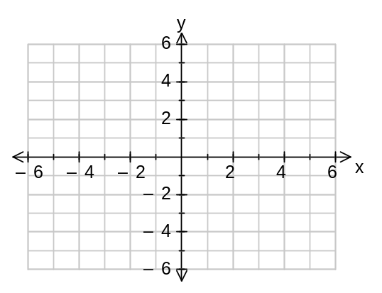  y = -x + 2

2. | Standard form
When the equation of a line is written in the form
ax + by = c
it is said to be in standard form.

When the equation is written in standard form, it is easy to find both the x and y intercepts by the method outlined below:-
Examples
a) | 3x + 2y = 12  To find the y intercept, put x = 0  (x = 0 is the equation of the y axis)  We have 3(0) + 2y = 12  i.e. 2y = 12  i.e. y = 6  so the y intercept is (0,6)  To find the x intercept, put y = 0  (y = 0 is the equation of the x axis)  We have 3x + 2(0) = 12  ie 3x = 12  ie x = 4  so the x intercept is (4,0)  Using these two points, we may graph the line – see right | 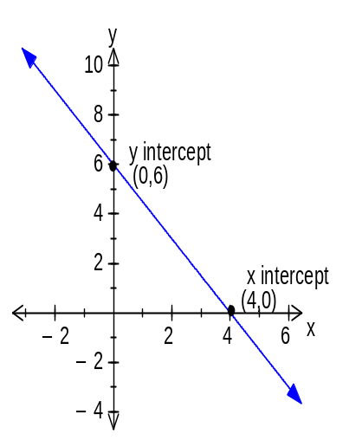
b) | x – 2y = -4  To find the y intercept, put x = 0  (x = 0 is the equation of the y axis)  We have (0) - 2y = -4  ie -2y = -4  ie y = 2  so the y intercept is (0,2)  To find the x intercept, put y = 0  (y = 0 is the equation of the x axis)  We have x - 2(0) = -4  ie x – 0 = -4  ie x = -4  so the x intercept is (-4,0)  Using these two points, we may graph the line – see right | 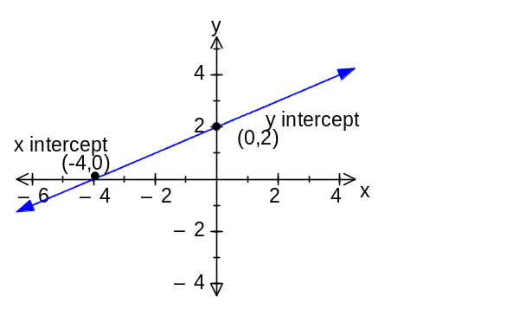

Using the method outlined above, graph the following lines:
c) | 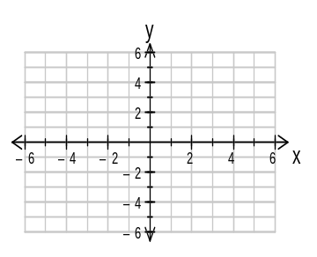  2x + y = 4 | d) | 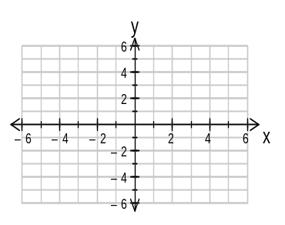  3x – 2y = 6
e) | 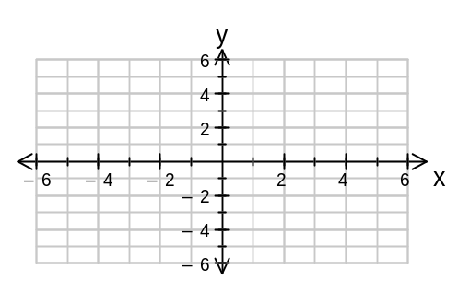  x + 3y = 3 | f) | 5x – 2y = 10
Note:
For the next two you will need to select a suitable scale yourself and possibly simplify one of the equations.
g) | 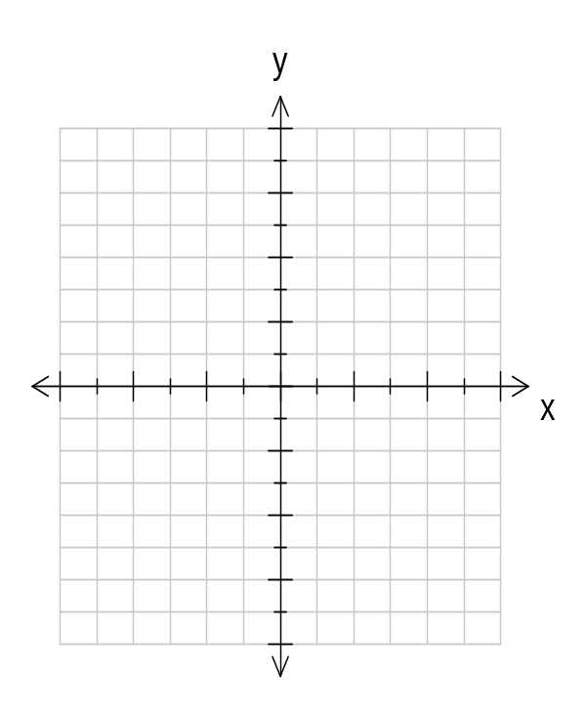  20x + 30y = 480 | h) | 18x + 12y = 3600

PART B RULES FROM TABLES
If a function is linear, then there is a constant first difference in the table of values which is equal to the value of the gradient.

The intercept may be found by finding the value of when (Often referred to as 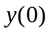

Using these facts we may sketch the graph using the procedure below:

a) | This function is linear since all the first differences are 3 i.e. for every increase of 1 in x (horizontally), there is an increase of 3 in y (vertically).  This means the gradient is 3 and the rule must be y = 3x + c  c is the vertical intercept – this is the value when x = 0. From the table, c = 5  Hence the rule is y = 3x + 5  [These two critical values in the table above have been enlarged and bolded]
  x | 0 |  | 1 |  | 2 |  | 3 |  | 4 |  | 5 |  | 6
  y | 5 |  | 8 |  | 11 |  | 14 |  | 17 |  | 20 |  | 23
  First difference |  | 8-5  =3 |  | 11-8  =3 |  | 14-11  =3 |  | 17-14  =3 |  | 20-17  =3 |  | 23-20  =3
b) | This function is linear since all the first differences are -5 i.e. for every increase of 1 in x (horizontally), there is a decrease of 5 in y (vertically).  This means the gradient is -5 and the rule must be y = -5x + c  c is the vertical intercept – this is the value when x = 0. From the table, c = 8  Hence the rule is y = -5x + 8  [Again these two critical values in the table above have been enlarged and bolded]
  x | 0 |  | 1 |  | 2 |  | 3 |  | 4 |  | 5 |  | 6
  y | 8 |  | 3 |  | -2 |  | -7 |  | -12 |  | -17 |  | -22
  First difference |  | 3-8  =-5 |  | -2-3  =-5 |  | -7--2  =-5 |  | -12--7  =-5 |  | -17--12  =-5 |  | -22--17  =-5
Find the rules for the linear functions determined by the tables below :-
c) | y = ____________
  x | 0 |  | 1 |  | 2 |  | 3 |  | 4 |  | 5 |  | 6
  y | 3 |  | 5 |  | 7 |  | 9 |  | 11 |  | 13 |  | 15
  First difference
d) | y = ____________
  x | 0 |  | 1 |  | 2 |  | 3 |  | 4 |  | 5 |  | 6
  y | 5 |  | 4 |  | 3 |  | 2 |  | 1 |  | 0 |  | -1
  First difference
e) | y = ____________
  x | 0 |  | 1 |  | 2 |  | 3 |  | 4 |  | 5 |  | 6
  y | 13 |  | 9 |  | 5 |  | 1 |  | -3 |  | -7 |  | -11
  First difference
f) | y = ____________
  x | 0 |  | 1 |  | 2 |  | 3 |  | 4 |  | 5 |  | 6
  y | 27 |  | 38 |  | 49 |  | 60 |  | 71 |  | 82 |  | 93
  First difference
g) | y = ____________
  x | 0 |  | 1 |  | 2 |  | 3 |  | 4 |  | 5 |  | 6
  y |  |  | 7 |  | 10 |  | 13 |  | 16 |  | 19 |  | 22
  First difference
h) | y = ____________
  x | 0 |  | 1 |  | 2 |  | 3 |  | 4 |  | 5 |  | 6
  y |  |  | 64 |  | 57 |  | 50 |  | 43 |  | 36 |  | 29
  First difference
i) | y = ____________
  x | 0 |  | 2 |  | 4 |  | 6 |  | 8 |  | 10 |  | 12
  y |  |  | 10 |  | 14 |  | 18 |  | 22 |  | 26 |  | 30
  First difference

PART C RULE FROM A GRAPH
 | The equation of a line may be worked out from its graph.
a) | For the graph at right, we can see that the gradient is 2 (for every 1 unit to the right, the graph increases by 2 vertically).  Also, the vertical intercept is -3.  Hence the equation is y = 2x - 3 | 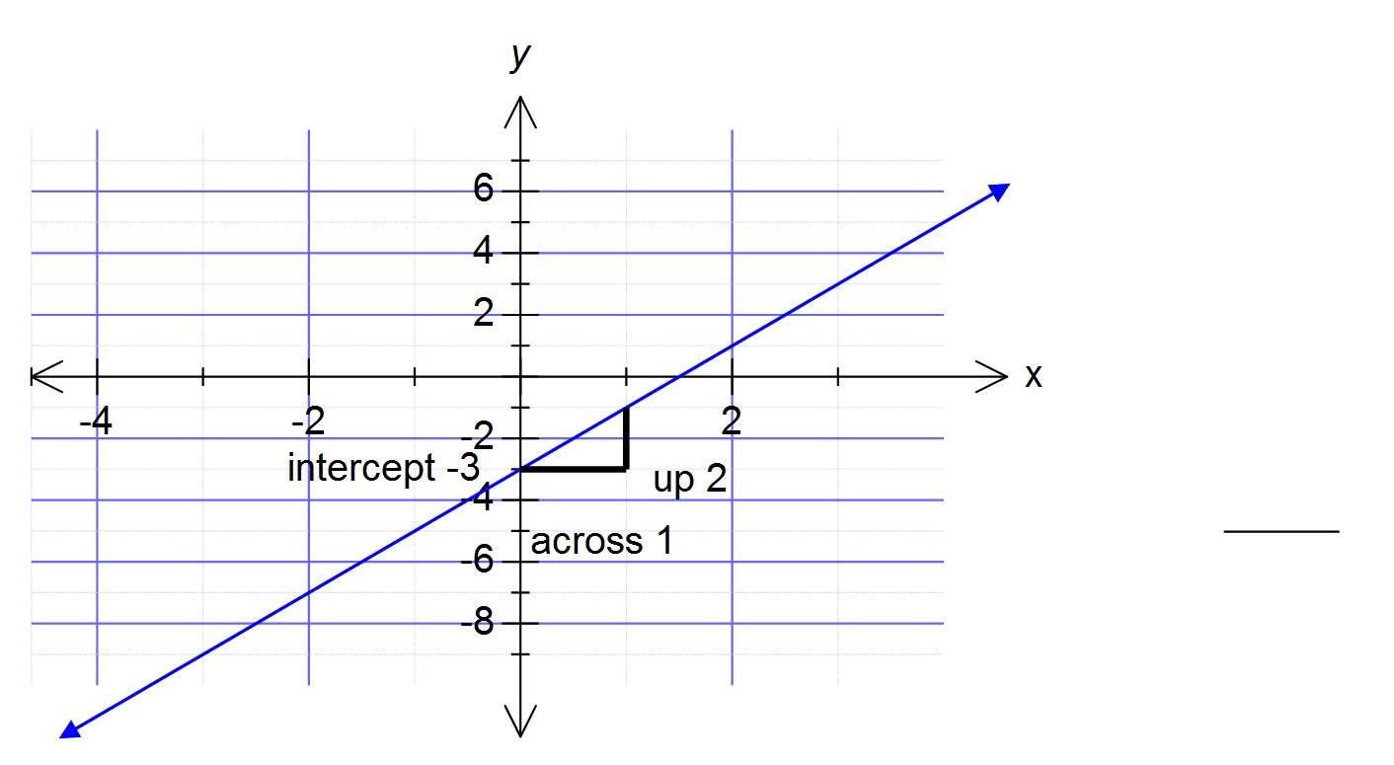
b) | For the graph at right, we can see that the gradient is -2/3 (for every 3 units to the right, the graph decreases by 2 vertically).  Also, the vertical intercept is 5.  Hence the equation is  y = -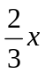 + 5 | 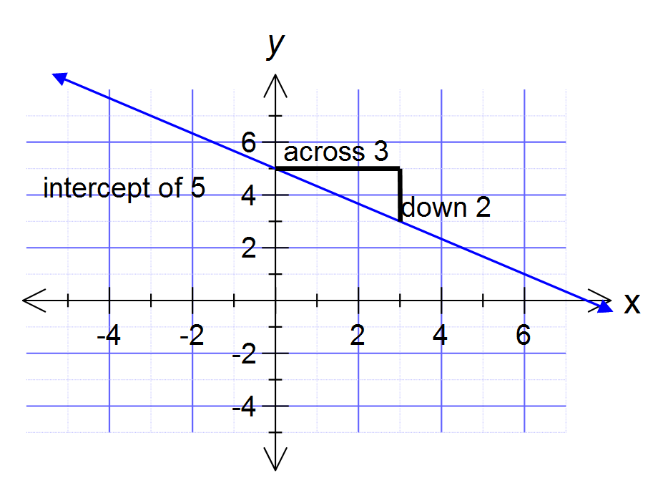
 | State the equations of the lines graphed below:-
c) | 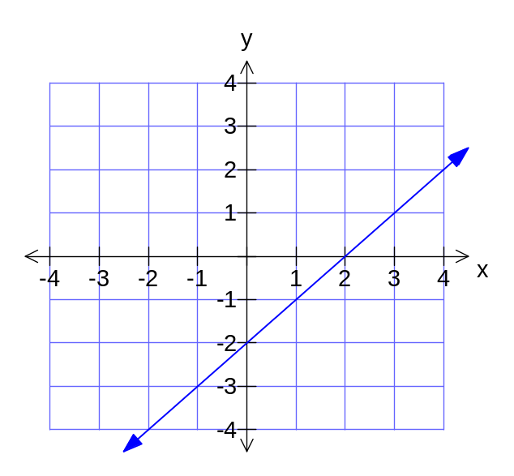 y = ____________ |  | d) | 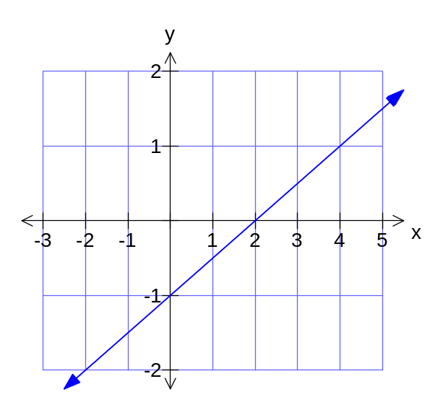  y = ____________
e) | 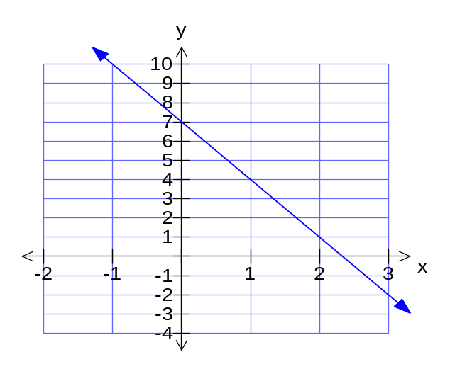 y = ____________ |  | f) | 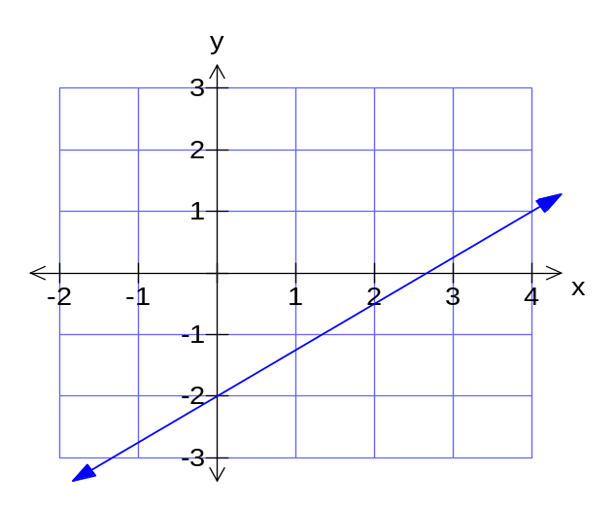 y = ____________

